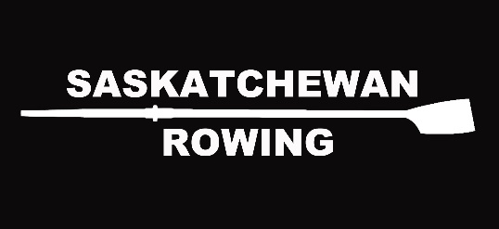

Summer Development Coach
Based in Lloydminster
This is a 30 hours per week position
Dates: June 19 – August 13, 2023 8 weeks
Wage: $16/hr

Roles and Responsibilities -

The Saskatchewan Rowing Association (SRA) is seeking one qualified Summer Development Coach who shall be responsible for creating and running Learn to Row and Come and Try activities at the Lloydminster Rowing Club. This coach will also run rowing programming in coordination with the Lloydminster Club Board and President. Programming may include morning rows for Junior athletes, afternoon Learn to Rows, and evening Senior/Master Rows. The Coach provides an enjoyable experience that will encourage participants to become further involved with Rowing in Saskatchewan. The goal of a Summer Development Coach is to create a fun atmosphere for participants through confident instruction, enthusiasm and safety. His/her interaction with summer program participants and/or parents will be central to the impressions of the SRA and the sport of rowing formed by newcomers. Additionally, the Coach is a role model for newcomers, as well as experienced athletes, and his/her ability to handle stressful situations in a mature manner along with strong conflict resolution skills are paramount in ensuring that everyone at the events has a fun and successful summer. The Coach reports to the Lloydminster Club President/Manager.

Rowing Development & Coaching - Club
- Coach/instruct Learn to Row training sessions/camps
- Assist with and instruct high-school, private and corporate LTR programs
- Assist with welcoming new members to the Club. Help new members find their way around the club
- Assist Club Manager with coordination of Club-wide events
- Assist with day-to-day management of boathouse activities (membership demands, program demands, keeping boathouse tidy, etc.)
- Assist with Boat repairs and club clean-up as required
- Other duties as assigned
- Work closely with clubs to ensure that any Covid-19 prevention protocols are implemented

Training
- Staff will receive training at the beginning of the work term regarding:
  - Safe operation of safety boats
  - Safety procedures at host club
  - Safe handling of materials used for boat repair (PPE provided)
  - Rigging training
Qualifications
- LTR Trained with completion of MED, Rowing Essentials & Coaching Initiation in Sport
- Knowledge of the sport of rowing
- Ability to coach sweep and scull rowing
- Coaching experience preferred
- CPR-C and AED certification preferred
- Pleasure Craft License
- Successful completion of a Sterling Backcheck Criminal Background Check with Vulnerable Sector Search
- Must be willing to work some evenings and weekends to accommodate rowing schedule
- Must be willing to travel to and reside in Lloydminster during work hours

Apply by sending resume and cover letter to SRA Hiring Committee: skrowoffice@gmail.com
Closing date May 11, 2023

